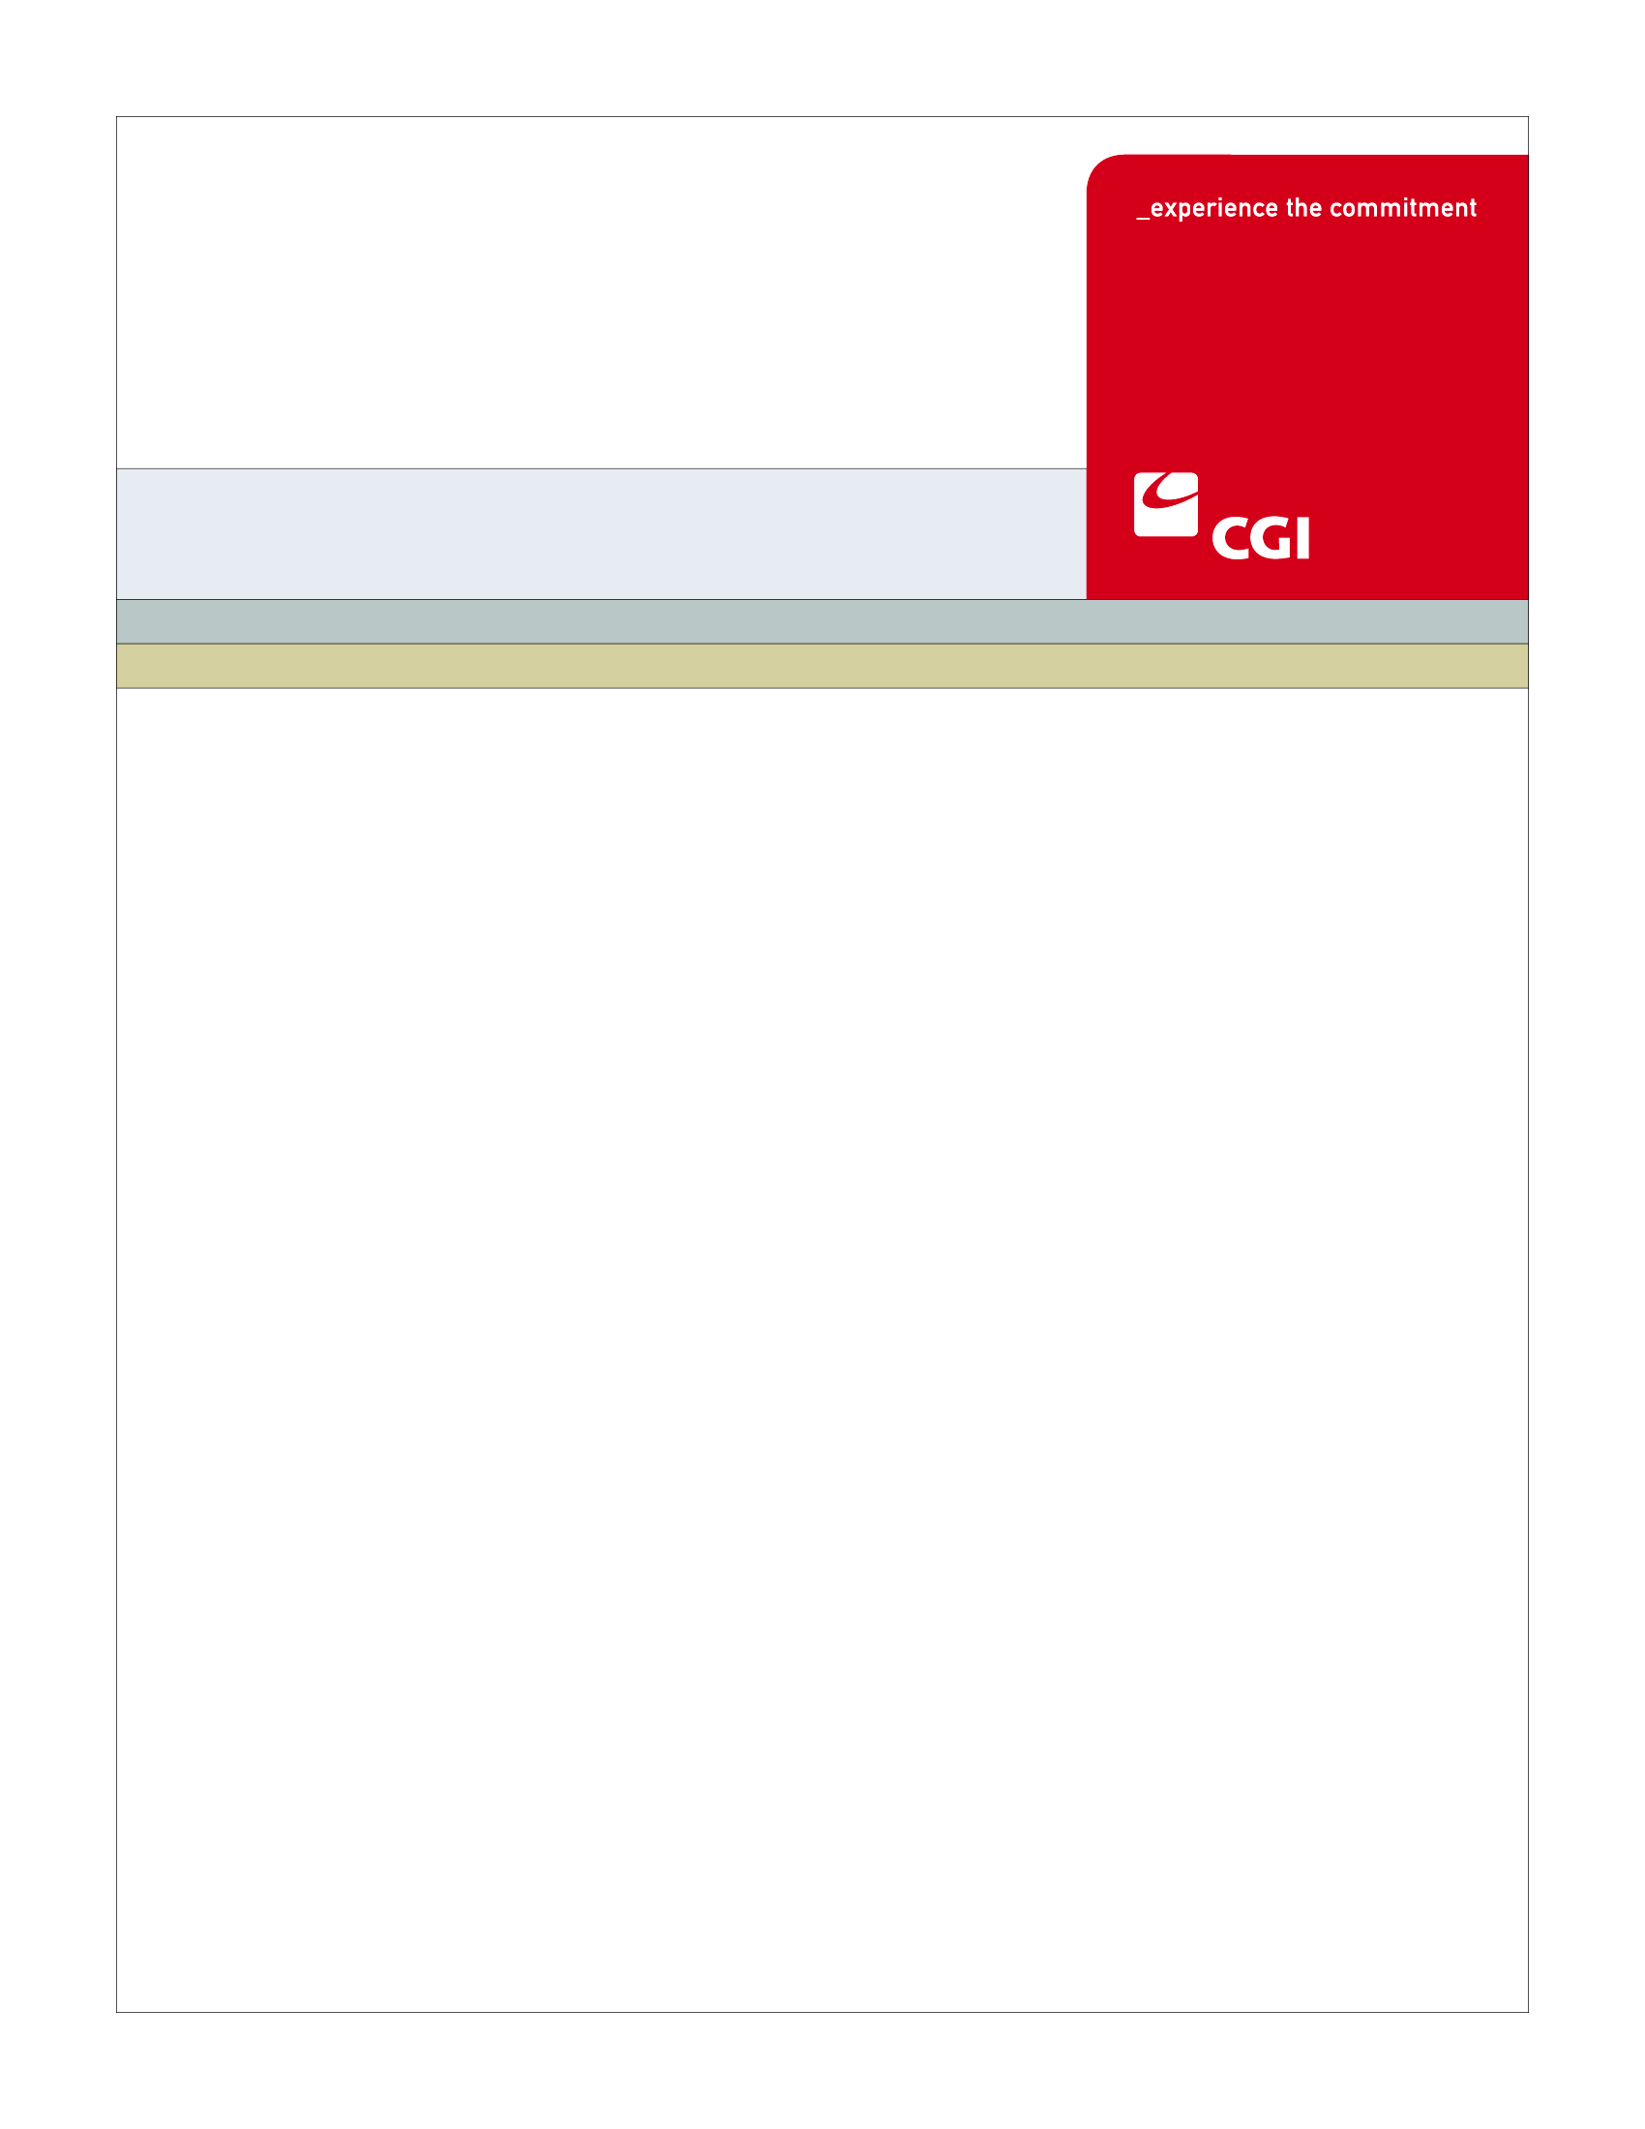USE

**Colorado Health Benefit Exchange (COHBE)**

**Create Broker Account Use Case**

**Version 1.1**

**October 18, 2012**

REVISION HISTORY

|  |  |  |  |
| --- | --- | --- | --- |
| Version | Date | Modified By | Description |
| 0.1 | 9/25/2012 | Diane Dunn | Initial draft for JAD Discovery Session |
| 0.2 | 10/2/2012 | Diane Dunn | Elaboration version; incorporating Discovery info |
| 0.3 | 10/10/2012 | Diane Dunn | Verification version, incorporating Elaboration info |
| 1.0 | 10/11/2012 | Diane Dunn | Incorporating comments from Verification Session |
| 1.1 | 10/18/12 | Diane Dunn | Accepting changes suggested by John Barela. Add Supported Language field to screen, data table. |
|  |  |  |  |
|  |  |  |  |
|  |  |  |  |
|  |  |  |  |
|  |  |  |  |
|  |  |  |  |
|  |  |  |  |
|  |  |  |  |

TABLE OF CONTENTS

1 Use Case: Create Broker Account 5

1.1 Goal 5

1.2 Brief Description 5

1.3 Requirements Traceability 5

1.4 Primary Actor 5

1.4.1 Broker 5

1.4.2 Service Representatives 5

1.5 Secondary Actor 5

1.5.1 Exchange 5

1.6 Pre-Conditions 6

1.7 Successful Post-Conditions 6

1.8 Triggers 6

1.9 Assumptions 6

2 Flow of Events 6

2.1 Basic (Main) Flow – Create Broker Account for New User 7

2.1.1 Register to Create a Broker Account 7

2.1.2 Enter Basic Account Information 7

2.1.3 Existing Account for Broker? 7

2.1.4 Create Account 8

2.1.5 Send Confirmation 8

2.1.6 Next Step 8

3 Alternate Flows 8

4 Exception Flows 8

4.1 Existing Account Found for User 8

4.1.1 Prompt User to Remember Credentials 8

4.2 User Exits without Creating an Account 8

5 Specifications 9

5.1 Business Rules 9

There are no business rules for the Create Broker Account Use Case. Required fields and formats are documented in section 5.10. 9

5.2 Process Rules 9

5.2.1 Existing Account for User? 9

5.3 Workflow 9

5.4 UI Screen Details 9

5.4.1 Broker Registration Screen 9

5.5 Communications 10

5.5.1 Imaging Requirements 10

5.5.2 Form Requirements 11

5.5.3 Notices Requirements 11

5.5.4 Other Communication Requirements 11

5.6 Interfaces 11

5.6.1 No Interfaces 11

5.7 Reporting 11

5.7.1 Business Intelligence/Reporting Needs 11

5.8 User Security 11

5.8.1 Password Security Properties 11

5.8.2 Data Transmission Requirements 11

5.9 Activity Log and Audit Trail 11

5.9.1 Activity Log 11

5.9.2 Audit Trail 12

5.10 Data Elements 12

6 Future Release Notes 14

7 Appendix A - Glossary 14

# Use Case: Create Broker Account

## Goal

The goal of this Use Case is to successfully create a Broker Account to log into the Exchange.

This Use Case completes succesfully when the account is created and the broker has a unique broker user ID and password to log into the Exchange.

## Brief Description

A broker account must be established to allow access to manage customers, plans, applications, and proposals on the Exchange. After the actor navigates to the register screen in the Broker Portal, basic information is entered to create an account. When submitted, the system checks to see if an account for the broker already exists in the Exchange system. If no existing account is found, the account is created and an electronic notification is sent to the broker. If an account is found, the user will be prompted for login credentials.

## Requirements Traceability

The following requirements are covered within this Use Case:

* GF077: Third parties such as carriers, navigators and brokers each will have an entry point into the Exchange in order to perform all of their required activities.

## Primary Actor

### Broker

A Broker will access the Exchange to create their account.

### Service Representatives

Removed for separate tracking.

## Secondary Actor

### Exchange

The Exchange will track and store account information for users of the Exchange.

## Pre-Conditions

* Primary Actor selects Broker Portal.

## Successful Post-Conditions

* An Account is created for the Broker with associated broker account ID and password stored in the system.
* The Broker account will be in a status of New awaiting certification.
* A Notification is sent to the Broker with account information.
* Data elements listed as required in section 5.10 are populated.

## Triggers

The following events trigger this Use Case:

* A Broker decides to create an account.

## Assumptions

* All primary actors will have the same capabilities in all functional flows – therefore any reference to a Broker will apply to any of the primary actors.
* Change Request 85 will be done prior to go-live. Change Request 85: The System should allow a Broker to set up an account with multiple logins so that multiple people can log in and create proposals, manage their clients, etc. There should be role specific privileges assigned to each log-in. At this time, the requirement does not include segregation of data or creation of reports for each user/sub-account.
* A background check will be done by an external service. Broker authorization to conduct the check will be included in this use case.

# Flow of Events

The Business Process Activity diagram below shows the COHBE processes for the Create Broker Account Use Case. The steps numbered on the diagram below have detailed explanations in the sections that follow.



## Basic (Main) Flow – Create Broker Account for New User

### Register to Create a Broker Account

* Access to Create Broker Account by:
  + Clicking the “Register” link at the top of the broker page.
  + Click the “Register Here” on the broker page

### Enter Basic Account Information

* The actor will enter the Basic Account Information.
* See Business Rules, Section 5.1.1 for the fields on the basic information page.
* Fields are edited for completeness and validity. If any errors exist, the actor is prompted to correct them before proceeding (Business Rules, Section 5.1.1)

### Existing Account for Broker?

The Exchange system will have the ability to check if an existing account is in the system (Process Rules, Section 5.2.1). In the basic flow, if an existing user is not found, the system will proceed to the next Step 2.1.4, Create Account. If there is an existing account, the exception flow is entered at Step 4.1.1, Prompt User to Remember Credentials.

### Create Account

The basic information entered will be used to create an account in the Exchange. A record will be saved to the database and a unique account number will be associated to the broker account record.

### Send Confirmation

After the account is created, the system sends a notice to the Broker confirming the account was created. The process then goes to Next Step.

### Next Step

At this point, the actor will only be allowed to go to Manage Broker Information (My Account). All else is locked down until the Certification is complete.

# Alternate Flows

There are no alternate flows for Create Broker Account.

# Exception Flows

## Existing Account Found for User

### Prompt User to Remember Credentials

If an existing account is found to exist in the Exchange, an error will be returned to the screen saying the account exists. The user can click on Forgot Password? Or Forgot Log In? When clicked, the system proceeds to the Manage Password Use Case (AM-007).

## User Exits without Creating an Account

An actor may exit the Create Broker Account use case by choice at any time. If this happens, the actor must restart the Create Account process.

# Specifications

## Business Rules

### There are no business rules for the Create Broker Account Use Case. Required fields and formats are documented in section 5.10.

## Process Rules

### Existing Account for User?

Step 2.1.3 will check for an existing account associated with the user based on the basic information fields. The check will be performed to confirm:

* Existing Broker User ID
* Existing email address
* Broker License Number (regardless of status of account)

## Workflow

There will be no workflow for the Create Broker Account Use Case.

## UI Screen Details

### Broker Registration Screen

The current fields are (asterisk indicates a required field):

* Broker/Agent* Radio Button Choice
* Email Address*
* Password*, Password Confirmation*
* Company Name
* Broker/Agent ID*
* First Name*
* Last Name*
* Address*
* Zip Code*
* County*
* State*
* Upload Documents (with a Browse button)
* Register button

The following changes are needed. See Business Rules, Section 5.1.1 for which fields are required and which are optional.

Remove the following field:

* Broker/Agent* Radio Button Choice

Modify the following fields:

* From Company Name to Agency Name
* From Broker/Agent ID to Broker License Number
* From First Name to State License First Name
* From Last Name to State License Last Name
* From Address to Address 1

Add the following fields:

* COHBE Account ID (Display Only, populated only after account creation)
* Broker User ID
* Agency Website URL
* State License Middle Name
* First Name to Display in Exchange
* Middle Name to Display in Exchange
* Last Name to Display in Exchange
* Address 2
* City
* Phone Number
* Supported Language 1
* Supported Language 2
* Supported Language 3
* Security Question 1
* Security Answer 1
* Security Question 2
* Security Answer 2
* Security Question 3
* Security Answer 3
* Terms and Conditions link and check box

## Communications

### Imaging Requirements

The uploaded documents used in certifying the broker (and loaded through this Use Case) are retained in the Enterprise Content Management (ECM) system.

### Form Requirements

There are no form requirements for the Create Broker Use Case.

### Notices Requirements

All broker accounts will receive an email notice advising the broker an account was created for the business. The notice will be a welcome to the Exchange message as well as a short description of the next steps regarding Certification process.

### Other Communication Requirements

There are no other communication requirements for the Create Broker Account Use Case.

## Interfaces

### No Interfaces

There are no interfaces for the Create Broker Account Use Case.

## Reporting

### User Experience

There are no User Experience reporting needs for the Create Broker Account Use Case.

### Business Activity

* Number of accounts created (total)
* Number of accounts created by Brokers
* Number of accounts created from out of state addresses

### Workflow

There are no Workflow reporting needs for the Create Broker Account Use Case.

### Community and Public Health

There are no Community and Public Health reporting needs for the Create Broker Account Use Case.

## User Security

### Actor Status Changes

A Broker account is created and moved to the pending certified.

### Sensitive Data Used

No sensitive data is used in the use case

### Data Transmission Requirements

There are no data transmission requirements for the Create Broker Account Use Case.

## Activity Log and Audit Trail

No changes tracked at this time

## Data Elements

The table below shows data elements that will be used to create the broker account.

| Process Step Reference  **\*Required Field** | Field Name  **\*Required Field** | Required Field? | Action Taken | Actor Performing Action | Format, if known |
| --- | --- | --- | --- | --- | --- |
| 2.1.2 | Email Address | Required | Create | User | name@domain.extension |
| 2.1.2 | Password | Required | Create | User |  |
| 2.1.2 | Re-type Password | Required | Create | User |  |
| 2.1.2 | Broker User ID | Required | Create | User | Pre-popualted with the email address and editable |
| 2.1.2 | Agency Name | Optional | Create | User |  |
| 2.1.2 | Agency Website URL | Optional | Create | User |  |
| 2.1.2 | Colorado License Number | Required | Create | User |  |
| 2.1.2 | COHBE Account Number | Required | Create | User | Generated after successful submission |
| 2.1.2 | State License First Name | Required | Create | User |  |
| 2.1.2 | State License Middle Name | Optional | Create | User |  |
| 2.1.2 | State License Last Name | Required | Create | User |  |
| 2.1.2 | First Name to Display in Exchange | Required | Create | User | defaulted from License Name and editable |
| 2.1.2 | Middle Name to Display in Exchange | Optional | Create | User | defaulted from License Name and editable |
| 2.1.2 | Last Name to Display in Exchange | Requried | Create | User | defaulted from License Name and editable |
| 2.1.2 | Address 1 | Required | Create | User |  |
| 2.1.2 | Address 2 | Optional | Create | User |  |
| 2.1.2 | City | Required | Create | User |  |
| 2.1.2 | Zip Code | Required | Create | User |  |
| 2.1.2 | County | Required | Create | User |  |
| 2.1.2 | State | Required | Create | User |  |
| 2.1.2 | Phone Number | Required | Create | User |  |
| 2.1.2 | Security Question 1 | Required | Create | User | Predefined list of questions from drop down |
| 2.1.2 | Security Answer 1 | Required | Create | User |  |
| 2.1.2 | Security Question 2 | Required | Create | User | Predefined list of questions from drop down |
| 2.1.2 | Security Answer 2 | Required | Create | User |  |
| 2.1.2 | Security Question 3 | Required | Create | User | Predefined list of questions from drop down |
| 2.1.2 | Security Answer 3 | Required | Create | User |  |
| 2.1.2 | Terms and Conditions | Required | Create | User | This will include authorization for background check |
| 2.1.2 | Upload Documents | Optional | Create | User |  |
| 2.1.2 | Supported Language 1 | Required | Create | User | Chose from drop down list. (The languages the broker is comforatable doing business in. |
| 2.1.2 | Supported Language 2 | Required | Create | User | Chose from drop down list. Default to Not applicable. |
| 2.1.2 | Supported Language 3 | Required | Create | User | Chose from drop down list. Default to Not applicable. |

# Future Release Notes

COHBE may be using a Master General Agent (MGA) in the management of brokers. A change request will be created, if needed, to address the role of MGAs and how they are to be integrated to the system. The change request will also outline any broker agency needs as well.

The Roadmap includes the inclusion and usage of the Broker’s Logo on hCentive screens.

# Appendix A - Glossary

| Term | Definition |
| --- | --- |
| Account | An “Account” is the means by which a user can access a computer system |
| Activity Log | An “Activity Log” is a chronological record of every action taken by each user, and by the System on behalf of each user.  The activity log includes actions and events pertaining to transactions, workflow, security (including SIEM), Alerts, Notifications, Approvals and interactions between the user and the System such as submissions of forms, data and documents. |
| Agency Agreement | An Agency Agreement is an agreement which allows the agent to act on behalf of the person or employer. When a broker is the agent of an employer, they assume liability for their acts while working on behalf of the employer. By being the agent, they act in the interest of the employer rather than themselves. |
| Audit Trail | An “Audit Trail” is a subset of records in the Activity Log that are selected and correlated by criteria provided by the auditor or requesting authority. |
| Authorization | “Authorization” is confirmation by a higher or secondary authority of the validity of an action taken by either a lower or primary actor of workflow on the System |
| Brokers | “Brokers” are persons authorized to assist Employers and or Individuals in their activities to shop for insurance through the Exchanges. |
| Carriers | “Carriers” are providers of insurance who will sell Qualified Health Plans (QHPs) in the Exchange. Occasionally, the term Health Plans is used to mean Carriers. Where it is not clear if the term Health Plan means an offering of a Carrier or the Carrier itself, the context should be used to help clarify meaning. Carriers may also be referred to as “Issuers”. |
| COHBE | Colorado Health Benefit Exchange, “COHBE” is used interchangeably with “Exchange” throughout the documents. |
| Customer | “Customers” or “Consumers” may be used interchangeably and are terms meant to define individuals or small employers or employees of small employers learning about opportunities to purchase, shopping to purchase, purchasing insurance through the Exchange, or modifying insurance purchased through the Exchange. References to Customers include, as appropriate, dependents of Customers, employees and dependents of employees and others covered by insurance purchased by Customers through the Exchange. |
| DBA | Doing Business As. A legal entity may choose to do business with one or more names. |
| DOI | The Colorado “Division of Insurance” regulates the insurance industry and assists consumers and other stakeholders with insurance issues. |
| DOI Authorization Standards | At this time Brokers are required to comply with the DOI Broker certification exam. Navigator’s authorization standards are TBD. |
| Employer | An “Employer” is a company or small business who participates in the Exchange to offer insurance and/or premium assistance to its Employee(s) or its Employee(s) and their dependents. |
| Escalation | “Escalation” shall mean re-assignment by the System or a user of the System of an action to a higher authority. |
| Exchange | During the implementation phase, the terms “Exchange” or “Exchanges” are meant to include technology, services, business processes, people, and other resources required to implement, operate and/or maintain the requirements or functions needed to support the ability for consumers to shop for and purchase health insurance. Specifically related to interpretation of a requirement, the term “Exchange” implies that the implementation of a requirement is not strictly limited to a technology solution.   * Individually, the term “Exchange” refers to each Exchange or both Exchanges as appropriate in the context. * The Exchange is NOT a state agency but a standalone non-profit entity. It will serve as an aggregator of individual policies sold by private insurers and underwritten using the new federal and state underwriting and rating rules. * The Small Business Health Options Program (SHOP) Exchange will support the specific needs of small employers. * For context, the Exchanges will act much like an “Expedia or Orbitz for Health Insurance” system. They will allow individuals and small firms to obtain information, compare and purchase private health insurance plans. The Exchanges will also be the entities that will evaluate whether or not a particular insurance policy meets the criteria set out by the new federal rules for policies offered to individuals and small employers. |
| External Broker | An external broker is one who uses the exchange, but only as a representative for a specific carrier. Commissions are paid by the carrier. |
| Internal Broker | An internal broker is one who uses the exchange as an independent broker, representing all Exchange carriers. Commissions are paid by the Exchange. |
| LMS | Learning Management System |
| Producer | In State statute, licensed brokers are called Producers. |
| Service Representatives | Service Representative (ServRep or SR): A COHBE representative who assists Participants, Customers, and/or Users in using the Exchange and/or the System. NOTE: CSR is used to mean Cost Sharing Reductions and shall not be used to mean ‘customer service representative’. |
| SHOP | Small Business Health Options Program |
| System | The “System” means all of the software, configurations, data, processes, and equipment used to provide the Exchanges and the System is also referred to as the “solution.” During the implementation phase, “System” is taken to mean the technology component of the Exchange. |
| Users | “Users” are users of the Exchange authorized by COHBE and may include operators, administrators, customers, brokers, navigators, etc., who interact with the System. Users may be internal or external to COHBE. |